MINI PROJECT: AGILE PLANNING & SCRUM IMPLEMENTATION
Enterprise Smart Library Management Platform
Trainer Guide + Student Activity Workbook
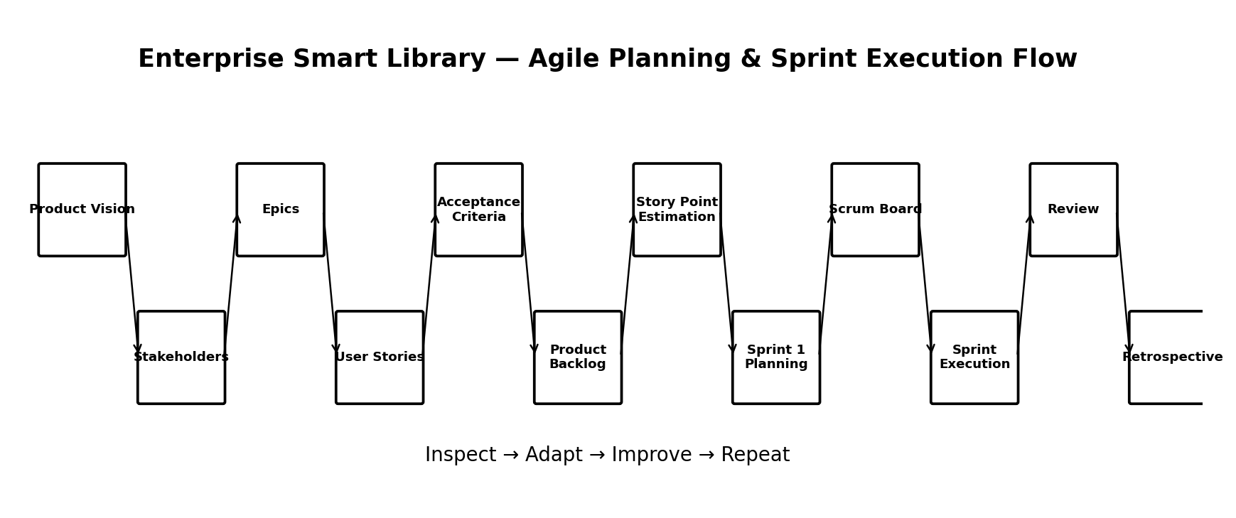

1. Project Objective
Enable students to apply Agile concepts by planning a complete software project collaboratively. Students work as Scrum Teams and transform a product idea into a Product Vision, Epics, User Stories, Acceptance Criteria, Product Backlog and Sprint 1 plan. They then simulate the Scrum events and demonstrate how inspection, feedback and adaptation improve the product.

Expected Learning Outcomes
- Explain how Agile concepts are applied to a real software project.
- Collaboratively define a Product Vision and identify stakeholders.
- Decompose a product into Epics and User Stories.
- Write measurable Acceptance Criteria.
- Prioritize and estimate a Product Backlog.
- Create and use a Scrum Board.
- Plan and simulate a Sprint.
- Participate effectively in Daily Scrum, Sprint Review and Sprint Retrospective.
- Explain how the same product could later be scaled using LeSS, SAFe or Scrum@Scale.

2. Project Scenario
The Enterprise Smart Library Management Platform is a software system for managing library users, books, borrowing, notifications, reports and administration. Students act as an Agile delivery team. The project is intentionally planned in increments so that the team can receive feedback after each Sprint.

Project Scope
Epic | Scope
User Management | Registration, Login, Logout, Password Management, User Profiles
Book Management | Add, Update, Delete, Search Books, Book Categories
Borrowing Management | Issue, Return, Renew, Due Date Management, Fine Calculation
Notifications | Due Date Reminders, Overdue Notifications, New Book Alerts
Reporting | Books Issued, Overdue Books, Popular Books, User Activity
Administration | Role Management, Backup, Audit Logs, System Configuration

3. Team Formation
Divide the class into Scrum Teams of approximately 5–8 students. Each team should have one Product Owner, one Scrum Master and the remaining students as Developers. If the class is large, several teams can work on the same product and compare their Sprint plans.
Role | Responsibility
Product Owner | Defines product value, clarifies requirements, orders the Product Backlog and accepts/rejects work against agreed criteria.
Scrum Master | Facilitates Scrum events, helps remove impediments, supports Scrum understanding and encourages continuous improvement.
Developers | Design, implement, test, document and integrate the product increment. The group jointly decides how to complete Sprint work.
Stakeholders | Represent librarians, library members, administrators, management and other users who provide needs and feedback.

4. Trainer Activity 1 — Define Product Vision
Trainer instruction: ask each team to write a one-paragraph Product Vision. The vision should explain who the product serves, the problem it solves and the value it creates.

Sample Product Vision
“For librarians, library members and administrators, the Enterprise Smart Library Management Platform provides a secure and efficient way to manage users, books, borrowing, notifications and reports, reducing manual work and improving the library experience.”

Task
- Identify the target users.
- Identify the main problem.
- Describe the expected business/user value.
- Keep the vision concise and outcome-focused.

5. Trainer Activity 2 — Identify Stakeholders
Stakeholder | Interest / Need
Library Administrator | System configuration, reports, audit and administration
Librarian | User registration, catalog management, issue/return operations
Library Member | Search books, borrowing status, notifications
Management | Usage, performance and business reports
IT/Support Team | Deployment, availability, security and maintenance

6. — Create Epics
An Epic is a large functional area that can be decomposed into multiple User Stories. Students should use the six major areas in the project scope.
User Management: Registration, Login, Logout, Password Management, User Profiles
Book Management: Add, Update, Delete, Search Books, Book Categories
Borrowing Management: Issue, Return, Renew, Due Date Management, Fine Calculation
Notifications: Due Date Reminders, Overdue Notifications, New Book Alerts
Reporting: Books Issued, Overdue Books, Popular Books, User Activity
Administration: Role Management, Backup, Audit Logs, System Configuration
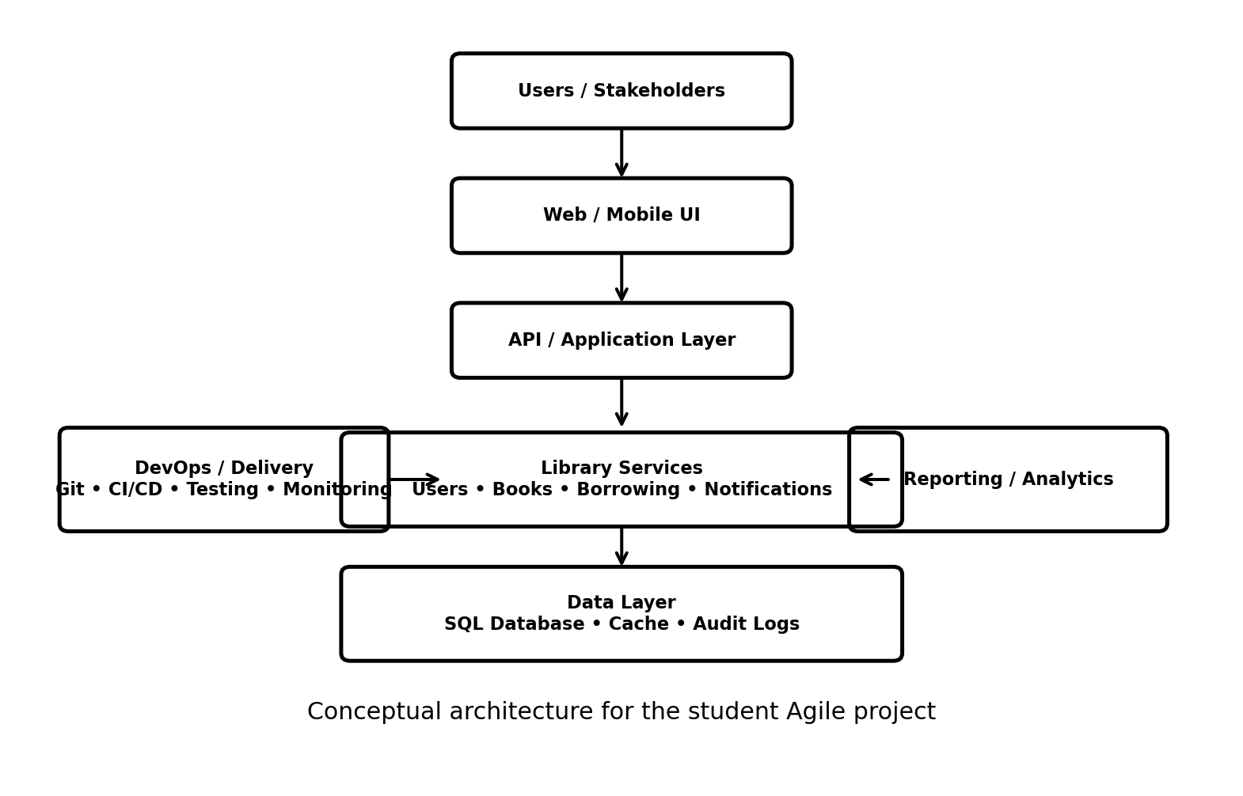
Architecture note: the diagram is a conceptual architecture for planning and discussion. Students are not required to implement every layer during Sprint 1.

7. Trainer Activity 4 — Write User Stories
Use the standard format: As a [User], I want [Functionality], so that [Business Value].
Story | User Story
Register New User | As a librarian, I want to register new library members, so that they can borrow books.
Search Books | As a library member, I want to search books by title, so that I can quickly locate available books.
Issue Book | As a librarian, I want to issue books to registered members, so that borrowing records are maintained automatically.
Return Book | As a librarian, I want to record returned books, so that book availability and borrowing history remain accurate.
Due Date Reminder | As a library member, I want to receive a due-date reminder, so that I can return books on time.

8. Trainer Activity 5 — Define Acceptance Criteria
Acceptance Criteria define the conditions that must be satisfied before a User Story can be considered complete.

Example — Issue Book
- Book must be available.
- User must be registered.
- Due date should be generated automatically.
- Borrowing history should be updated.
- Confirmation message should be displayed.
As a librarian, I want to scan an ISBN or barcode to auto-populate book metadata (title, author, publisher, genre), so that I can catalog new acquisitions in seconds.
Acceptance Criteria: Metadata fetches via an open book API; fields remain manually editable.
2: As a patron, I want to filter the online catalog by availability, author, and format (eBook, hardcopy), so that I can quickly locate items ready for pickup.
Acceptance Criteria: Search results update in under 1 second; unavailable books show expected return dates.

9. Trainer Activity 6 — Prioritize Product Backlog
The Product Owner orders backlog items according to business value, dependencies, risk and stakeholder needs. The backlog remains a living list and can change as feedback is received.
Order | Backlog Item | Priority | Business Value
1 | User Registration | High | Essential
2 | User Login | High | Essential
3 | Search Book | High | Essential
4 | Add Book | High | Essential
5 | Issue Book | High | Essential
6 | Return Book | High | Essential
7 | Password Reset | High | High
8 | Due Date Reminder | Medium | Medium
9 | Daily Library Report | Medium | Medium
10 | Borrowing Statistics | Medium | Medium
11 | Analytics Dashboard | Low | Low
12 | Audit Logs | Low | Low

10. Trainer Activity 7 — Estimate Story Points
Students estimate relative effort, complexity and uncertainty using a Fibonacci-like scale such as 1, 2, 3, 5, 8 and 13. Planning Poker can be used.
Story | Sample Points
Register User | 3
User Login | 2
Search Book | 3
Add Book | 5
Issue Book | 8
Return Book | 5
Password Reset | 5
Important: Story Points are relative estimates and should not be treated as exact hours.

11. Trainer Activity 8 — Plan Sprint 1
Sprint Goal: “Deliver a working foundation for user authentication and basic library access.”
Sprint Backlog Item | Suggested Points
Create repository | 2
Configure Git workflow | 2
Project structure | 3
User Registration | 3
User Login | 2
User Database | 5
Unit Testing | 3
Documentation | 2

Sprint 1 Deliverables
- Working registration module
- Working login module
- Basic user database
- Automated/unit tests for implemented functions
- Updated repository and documentation
- Sprint Review demonstration

12. Trainer Activity 9 — Create Scrum Board
Students visualize Sprint work using a board such as To Do → In Progress → Code Review → Testing → Done.

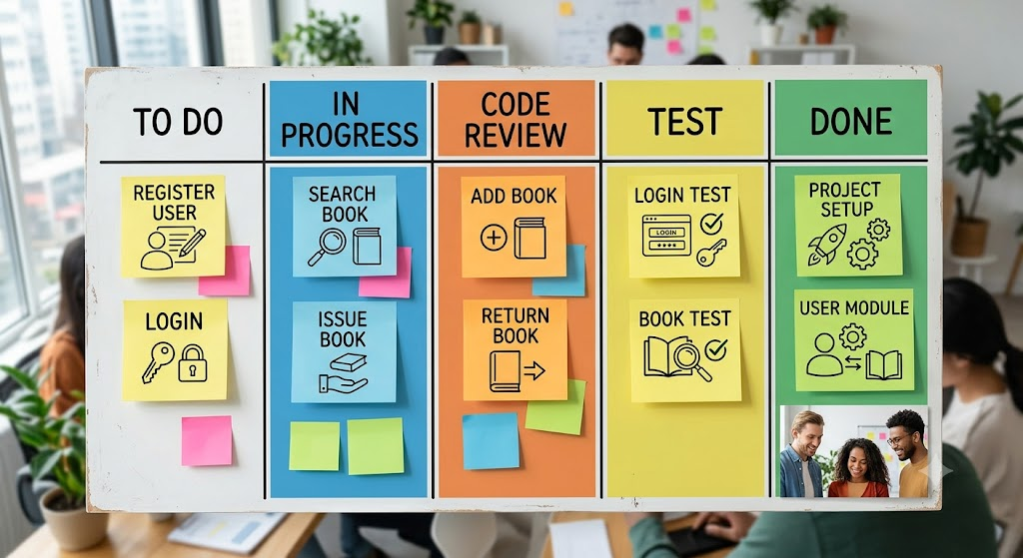

Trainer instruction: ask teams to move cards only when the work actually changes state. Discuss blocked items and excessive Work in Progress.

13. Trainer Activity 10 — Conduct Sprint Planning
- Confirm Product Goal and Sprint Goal.
- Review the highest-priority Product Backlog items.
- Clarify User Stories and Acceptance Criteria.
- Estimate or confirm Story Points.
- Discuss dependencies, risks and technical work.
- Select a realistic amount of work based on team capacity.
- Break selected stories into implementable tasks.
- Agree on the Definition of Done.
- Create the Sprint Backlog and Scrum Board.

14. Trainer Activity 11 — Simulate Daily Scrum
Run a short classroom simulation. Each Developer briefly communicates progress, next work and impediments.
- What did I complete?
- What will I work on next?
- What impediment or dependency needs attention?
Trainer observation: check whether the team is coordinating toward the Sprint Goal rather than merely reporting status to the Scrum Master.

15. Trainer Activity 12 — Sprint Review
At the end of the simulated Sprint, the team demonstrates the working increment. Stakeholders ask questions and provide feedback.

Example Review Scenario
The team demonstrates User Registration and Login. The librarian stakeholder asks for a member ID field and the administrator asks for a role-based access option. The Product Owner records these as new or refined Product Backlog items for future prioritization.
- Demonstrate completed functionality.
- Show acceptance criteria.
- Collect stakeholder feedback.
- Identify unfinished work.
- Update or reorder the Product Backlog.

16. Trainer Activity 13 — Sprint Retrospective
- What went well?
- What did not go well?
- What caused the difficulties?
- What should we continue?
- What should we stop or change?
- What one or two improvement actions will be applied in the next Sprint?
Expected output: a short improvement action list with an owner and a measurable follow-up.

17. End-to-End Project Flow
The team repeats the cycle: clarify value → prioritize → plan → build → inspect → receive feedback → adapt → plan the next increment.

18. Student Submission / Deliverables
- Product Vision
- Stakeholder Map
- Epic List
- User Story Repository
- Acceptance Criteria
- Prioritized Product Backlog
- Story Point Estimation Sheet
- Sprint Goal and Sprint Backlog
- Scrum Board screenshot/export
- Daily Scrum notes
- Sprint Review report
- Sprint Retrospective report
- Architecture diagram
- Final team presentation

19. Final Outcome
By completing this mini-project, students experience the complete Agile planning loop for a realistic software product: Product Vision → Stakeholders → Epics → User Stories → Acceptance Criteria → Product Backlog → Story Points → Sprint Planning → Scrum Board → Daily Scrum → Sprint Review → Sprint Retrospective. The project gives students a practical foundation for later DevOps topics such as Git, CI/CD, testing, containers, infrastructure automation and monitoring.

